New Blue e+ chiller variants for industry, renewable energies and IT
Rittal expands its liquid cooling portfolio
Herborn, 2025-10-01
By expanding its range in the field of liquid cooling for industrial and IT applications, Rittal now offers F-Gas-Regulation-compliant cooling solutions for almost every application area, from mechanical engineering to battery energy storage systems (BESSs) and IT. The expanded portfolio now focuses on new power classes ranging from 1.5 to 7 kW, outdoor models, and a hybrid IT chiller with an integrated free-cooler for exceptionally high energy efficiency.
Rittal, the system provider for hardware, software and automation, is further expanding the liquid cooling portfolio of its Blue e+ Chiller series for industry and IT, focusing on future-proof refrigerants that comply with the F-Gas Regulation. New power classes, ranging from 1.5 to 7 kW, and special outdoor models are available for this tried-and-tested cooling solution. A particularly energy-efficient hybrid IT chiller, available in 5.5- and 7 kW models with an integrated free cooling function, has also been added to the range.
One key feature of the new Blue e+ chiller variants is their exceptionally high temperature stability with an accuracy of as much as ±0.1 K in steady state. This precision greatly helps extend the service life of temperature-sensitive components and allows the production of high-precision workpieces, particularly in demanding industrial applications.
The high energy efficiency results from a central DC inverter that intelligently controls the DC compressor, the DC condenser fan and the electronic expansion valve. Energy savings of up to 70 per cent can be achieved compared to conventional cooling solutions, especially in partial load operation. The savings can even reach 90 per cent when hybrid IT chillers with a free cooling function are used. Integration into higher-level power management systems to monitor and control the cooling functions is possible, for example, in combination with the optional IoT interface. A touchscreen display ensures intuitive operation directly on the device itself. All new devices have international approvals and offer multi-voltage capability for global use.
Extended output classes for precise liquid cooling
For industrial applications, Rittal is expanding the standard version of the series to include the 1.5- and 7-kW output classes, in addition to the existing 2.5-, 4- and 5.5 kW versions. This makes it even easier for mechanical engineering users to find the correct device for their specific application area. The Blue e+ Chiller is particularly popular in mechanical engineering thanks to its high temperature accuracy, which ensures precise machine operation and compliance with tight material tolerances. This results in fewer production errors and failures, with components having a longer service life.
Robust outdoor option
In addition to the new output classes for indoor use, the Blue e+ Chiller is now also available as an outdoor version with 4, 5.5 and 7 kW as standard, available off the shelf. The robust aluminium enclosure, featuring a UV-resistant coating, and the weatherproof touchscreen display guarantee reliable outdoor use. As the device can pre-heat the cooling medium, it remains operational even at ambient temperatures as low as -20°C. The outdoor version can also withstand external temperatures of up to +43°C and ensures constant cooling to ideal operating temperatures when used outdoors. In this way, Rittal is opening up new applications for its climate control technology, for example, for battery energy storage systems (BESSs), which will be needed increasingly in the energy transition.
Highly efficient with free cooling
The expanded portfolio is rounded off by the Blue e+ hybrid IT chiller in the 5.5- and 7-kW output classes. These can be used in combination with an LCU CW, primarily in smaller IT applications of up to 30 kW. The option with a free cooler permits energy savings of 90 per cent compared to conventional cooling solutions. The integrated free cooling function automatically uses low external temperatures for passive heat dissipation via a heat exchanger. Active cooling is deactivated as soon as the environment is cooler than the internal target temperature. This significantly reduces energy consumption, especially in temperate climate zones or during periods of low temperatures. The standard Blue e+ hybrid IT chiller is just as weather-resistant as the Blue e+ Outdoor Chiller and thus ideally suited for outdoor use, for example, in combination with the Rittal Data Center Container. Together with Rittal’s LCU CW, the hybrid IT chiller also supports the rapid conversion to future-proof IT cooling solutions that comply with the F-Gas Regulation.

“By expanding our range of chillers, we are responding specifically to current market requirements,” explains Hakan Türe, Liquid Cooling Product Manager at Rittal: “our new models are ideally equipped for the challenges of tomorrow, whether it’s the wish for greater process reliability in mechanical engineering, the BESS boom, growing computing power in IT, or the need for devices that comply with the F-Gas Regulation.”

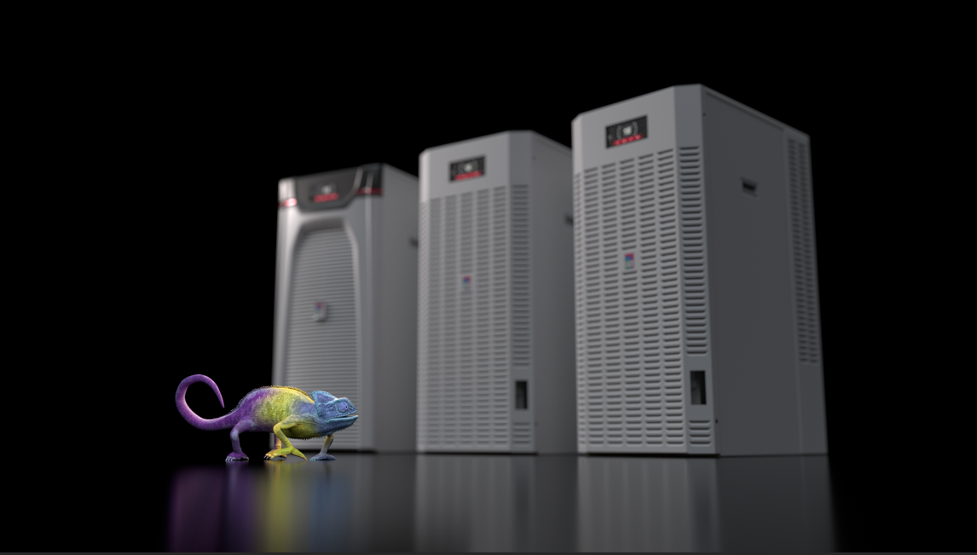 |  | 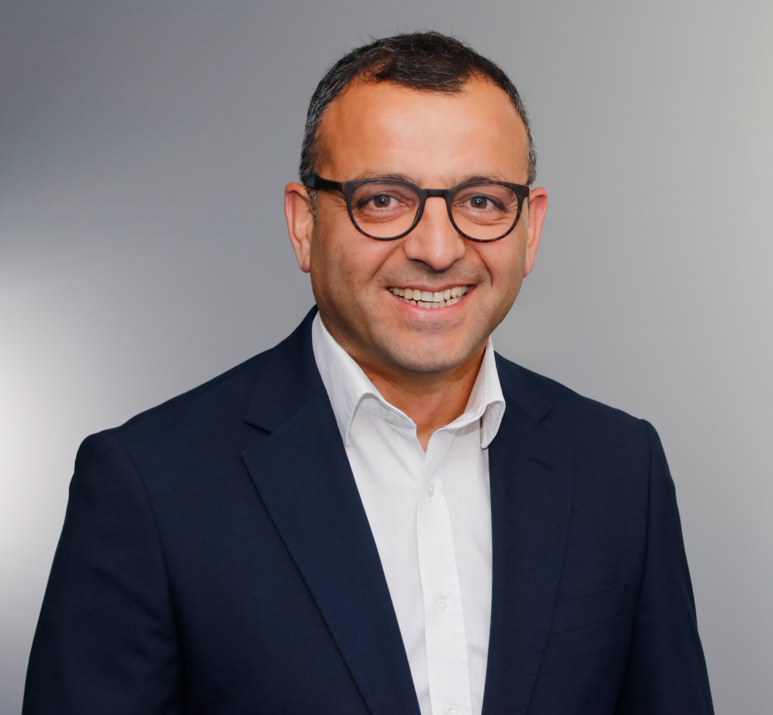
Caption, image 1  The chameleon symbolises the versatility of Rittal’s new chiller range. |  | Caption, image 2  Hakan Türe, Liquid Cooling Product Manager at Rittal: “By expanding our range of chillers, we are responding specifically to market requirements like higher process reliability in mechanical engineering, BESS, growing computing power in IT and the F-Gas Regulation.”

May be reproduced free of charge. Please name Rittal GmbH & Co. KG as source.

Rittal

Rittal is a leading global supplier of enclosure systems, automation and infrastructure with its industrial, IT, energy and power, cooling and service units. Rittal products and solutions are used in over 90% of global industries – standardised, customised, and always of the very best quality.
Our approach and methodology: Rittal, Rittal Software Systems (Eplan, Cideon and German Edge Cloud) and Rittal Automation Systems (RAS, Ehrt, Alfra) combine their hardware and software expertise to streamline, optimise and digitalise processes across the entire value chain for our customers including their IT infrastructure – from control and switchgear construction, machine building to factory operators or the energy sector.
Our delivery promise: Rittal standard products are delivered in Germany within 24 hours, and within 48 hours throughout Europe.
Customer focus
Improving efficiency and increasing productivity through automation and digitalisation is one of the biggest challenges for our customers. This requires in-depth knowledge and expertise, the combination of hardware and software, and cross-sector networking. We are convinced that creating and connecting data rooms is crucial to the success of industrial transformation. And that is exactly our speciality and field of competence.
Eplan and Rittal are driving the development of the digital automation twin, making data accessible and useable in operations as well. Cideon is improving data consistency in the digital product twin context with its CAD/CAM, PDM/PLM and product configuration expertise. German Edge Cloud’s ONCITE Digital Production System (DPS) makes production process data transparent, enabling it to be optimised – right through to energy management using digital production twins.
Sustainability
Environmental and climate protection, social commitment and ethical corporate management are a given for Rittal. We take our responsibility for a sustainable future seriously. Our approach to resource management and conservation involves continuous improvement of our own production processes and ensuring that our products have the lowest possible Product Carbon Footprint. Our solutions support our customers in achieving their own climate targets.
Family business and global player
Founded in 1961, Rittal is the largest company in the owner-operated Friedhelm Loh Group. The group operates worldwide, with 13 production sites and 95 international subsidiaries. It has 12,600 employees and posted revenues of 3.1 billion euros in fiscal 2024. In 2023, the Friedhelm Loh Group was presented with the “Best Place to Learn” and “Employer of the Future” awards. In 2024, Rittal was awarded the Top 100 Seal as one of Germany’s most innovative medium-sized companies for the fourth time in a row.
For more information, visit www.rittal.com and www.friedhelm-loh-group.com.

Corporate Communications
Dr. Carola Hilbrand Rittal GmbH & Co. KG
Corporate & Brand Communications Auf dem Stützelberg
Tel.: 02772/505-2527 35745 Herborn
hilbrand.c@rittal.de www.rittal.com

